LESSON PLAN

TO: Dr. Ristow
FROM: Charles Lewis
DATE: March 21, 2001
RE: Inclusive Strategy for 8th Grade Math: Square Area and Volume

GOAL: Teach computations necessary to calculate the square area and volume of three dimensional figures (including cylinders).

OBJECTIVE: Students will be able to calculate the square area and volume of three dimensional figures and specify appropriate units (² and ³)

MATERIALS USED: Overhead projector and slides

ACCOMMODATIONS: Special education students will be afforded use of calculators and a copy of Appendix B (Strategy for Computing Square Area and Volume) in compliance with IEPs

LESSON SEQUENCE:

- Explanation:

- Description of units
1. One dimensional 
2. Two dimensional ²
3. Three dimensional ³

- Compute the square area of a prism

SA = [(SA)Top x 2] + [(SA)Front x 2] + [(SA)Side x2]
= (Depth x Width x 2) + (Height x Width x 2) + (Depth x Height x 2)

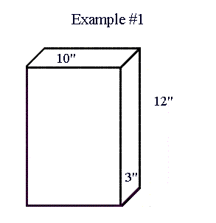
SA = 3 x 10 30
3 x 10 30
12 x 10 120
12 x 10 120
3 x 12 24
+ 3 x 12 24
348 in² (inches squared)

- Compute the volume of a prism
V = Height x Width x Depth
V = 12 x 10 x 3
= 360 in³ (inches cubed)
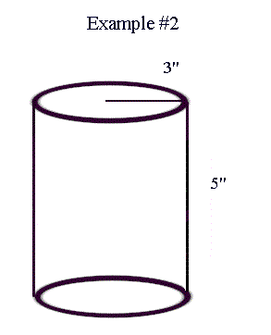
- Compute square area of a cylinder

SA = [(SA)Top x 2] + (SA)Side
= ( x r x r x 2) + ( x 2 x r x Height)

SA = ( x 3 x 3)  x 9 28.3
( x 3 x 3)  x 9 28.3
+ ( x 2 x 3 x 5)  x 30 94.2
150.8 in² (inches squared)

e. Compute volume of a cylinder

V = (SA)Top x Length

V = ( x 3 x 3) x 5
=  x 9 x 5
=  x 45
= 141.4 in³ (inches cubed)

- Demonstration: Work through the previous examples

- Discussion

- Application: Appendix A (Practical Exercise)

- Discussion prior to dismissal
Appendix A: Practical Exercise
Name ________________________ ____________
50 Points
Compute the Square Area and Volume for the following:
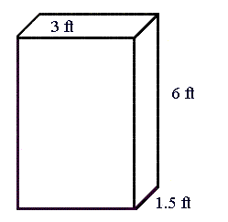
1. SA = ____________ V = ____________

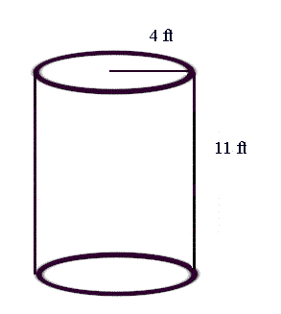

2. SA = ____________ V = __________

- A box has a length of 3.5", a width of 5.5", and a depth of 2.5" SA = ____________
V = ____________

- A cylinder has a radius of 4.5" and a height of 7.5" SA = ____________ V = ___________
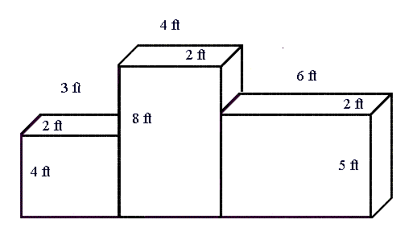
- SA = ___________
V = ___________
Appendix B: Strategy for Computing Square Area and Volume

- Description of units
1. One dimensional 
2. Two dimensional ²
3. Three dimensional ³

- Compute the square area of a prism

SA = [(SA)Top x 2] + [(SA)Front x 2] + [(SA)Side x2]
= (Depth x Width x 2) + (Height x Width x 2) + (Depth x Height x 2)

SA = Depth x Width
Depth x Width
Height x Width
Height x Width
Depth x Height
+ Depth x Height
in² (squared)

- Compute the volume of a prism
V = Height x Width x Depth
= in³ (cubed)

- Compute square area of a cylinder

SA = [(SA)Top x 2] + (SA)Side
= ( x r x r x 2) + ( x 2 x r x Height)

SA = ( x r x r)
( x r x r)
+ ( x 2 x r x Height)
in² (squared)

e. Compute volume of a cylinder

V = (SA)Top x Length
= ( x r x r) x Length
= in³ (cubed)

* A negative correlation between information provided and student individual effort can be achieved through the strategy sheet. Initial problems can be presented with the majority of computations filled in. As the student progresses through the strategies, less and less steps are provided. At the end, the student can be provided formulas (as in this example) and be expected, within reason, to complete the computations.

